SIGNOZ OTEL-COLLECTOR INSTALLATION – STANDALONE

curl -L https://github.com/SigNoz/signoz-otel-collector/releases/latest/download/signoz-otel-collector_linux_$(uname -m | sed 's/x86_64/amd64/g' | sed 's/aarch64/arm64/g').tar.gz -o signoz-otel-collector.tar.gz
tar -xzf signoz-otel-collector.tar.gz
The above commands from official doc of signoz is not working.
So installed docker in the vm and pull the official image of signoz-otel-collector.
STEP-1: Pull official docker image from hub.
docker pull signoz/signoz-otel-collector:latest-linux-amd64
STEP-2: Extract the collector binary from your Docker image
# Create a container from the image without running it
docker create --name tmp-collector signoz/signoz-otel-collector:latest-linux-amd64
# Copy the contents from the container to your host
docker cp tmp-collector:/signoz-otel-collector ./signoz-otel-collector
# Remove the temporary container
docker rm tmp-collector
STEP-3: Create directories for SigNoz OTEL Collector
sudo mkdir -p /opt/signoz-otel-collector/bin
sudo mkdir -p /opt/signoz-otel-collector/conf
sudo mkdir -p /var/lib/signoz-otel-collector
STEP-4: Move the binary into place
sudo mv signoz-otel-collector /opt/signoz-otel-collector/bin/
sudo chmod +x /opt/signoz-otel-collector/bin/signoz-otel-collector

STEP-5: Create a system user (if not already created)
sudo getent passwd signoz >/dev/null || sudo useradd --system --home /opt/signoz-otel-collector --no-create-home --user-group --shell /sbin/nologin signoz
sudo chown -R signoz:signoz /opt/signoz-otel-collector /var/lib/signoz-otel-collector
Make sure the permissions are like this:
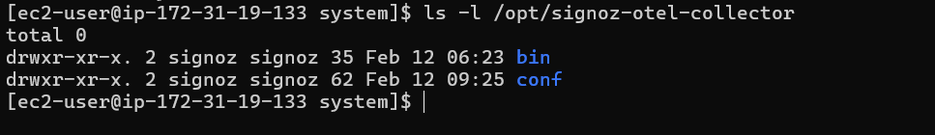
STEP-6: Create config.yaml
sudo bash -c 'cat <<EOF > /opt/signoz-otel-collector/conf/config.yaml
receivers:
otlp:
protocols:
grpc:
endpoint: 0.0.0.0:4317
max_recv_msg_size_mib: 16
http:
endpoint: 0.0.0.0:4318
jaeger:
protocols:
grpc:
endpoint: 0.0.0.0:14250
thrift_http:
endpoint: 0.0.0.0:14268
httplogreceiver/heroku:
endpoint: 0.0.0.0:8081
source: heroku
httplogreceiver/json:
endpoint: 0.0.0.0:8082
source: json
processors:
batch:
send_batch_size: 50000
timeout: 1s
signozspanmetrics/delta:
metrics_exporter: signozclickhousemetrics
latency_histogram_buckets: [100us, 1ms, 2ms, 6ms, 10ms, 50ms, 100ms, 250ms, 500ms, 1000ms, 1400ms, 2000ms, 5s, 10s, 20s, 40s, 60s]
dimensions_cache_size: 100000
dimensions:
- name: service.namespace
default: default
- name: deployment.environment
default: default
- name: signoz.collector.id
aggregation_temporality: AGGREGATION_TEMPORALITY_DELTA
extensions:
health_check:
endpoint: 0.0.0.0:13133
zpages:
endpoint: localhost:55679
pprof:
endpoint: localhost:1777
exporters:
clickhousetraces:
datasource: tcp://<CLICKHOUSE_VM_IP>:9000/signoz_traces?password=password
use_new_schema: true
signozclickhousemetrics:
dsn: tcp://<CLICKHOUSE_VM_IP>:9000/signoz_metrics?password=password
timeout: 45s
clickhouselogsexporter:
dsn: tcp://<CLICKHOUSE_VM_IP>:9000/signoz_logs?password=password
timeout: 10s
use_new_schema: true
metadataexporter:
dsn: tcp://<CLICKHOUSE_VM_IP>:9000/signoz_metadata?password=password
timeout: 10s
tenant_id: default
cache:
provider: in_memory
service:
telemetry:
logs:
encoding: json
extensions: [health_check, zpages, pprof]
pipelines:
traces:
receivers: [otlp, jaeger]
processors: [signozspanmetrics/delta, batch]
exporters: [clickhousetraces, metadataexporter]
metrics:
receivers: [otlp]
processors: [batch]
exporters: [metadataexporter, signozclickhousemetrics]
logs:
receivers: [otlp, httplogreceiver/heroku, httplogreceiver/json]
processors: [batch]
exporters: [clickhouselogsexporter, metadataexporter]
EOF'

NOTE: Here, Replace <CLICKHOUSE_VM_IP> with your ClickHouse VM IP.

STEP-7: Create opamp.yaml → This is causing trouble [no need]
sudo bash -c 'cat <<EOF > /opt/signoz-otel-collector/conf/opamp.yaml
server_endpoint: ws://127.0.0.1:4320/v1/opamp
EOF'
NOTE:
You need to replace 127.0.0.1 with the IP address of the SigNoz VM.
NOTE:
For the OTel Collector to connect via OpAMP, you need TCP port 4320 open to the collector VM.
Add a new rule to the SG:
Field | Value
Type | Custom TCP
Protocol | TCP
Port range | 4320
Source | Collector VM IP (172.31.19.133/32) or VPC CIDR (e.g., 172.31.0.0/16)
Description | OpAMP connection from collector

STEP-8: Create the SigNoz Otel Collector systemd service
sudo bash -c 'cat <<EOF > /etc/systemd/system/signoz-otel-collector.service
[Unit]
Description=SigNoz OTel Collector
Documentation=https://signoz.io/docs
After=network.target

[Service]
User=signoz
Group=signoz
Type=simple
KillMode=mixed
Restart=on-failure
WorkingDirectory=/opt/signoz-otel-collector
ExecStart=/opt/signoz-otel-collector/bin/signoz-otel-collector \
--config=/opt/signoz-otel-collector/conf/config.yaml \
--manager-config=/opt/signoz-otel-collector/conf/opamp.yaml \
--copy-path=/var/lib/signoz-otel-collector/config.yaml

[Install]
WantedBy=multi-user.target
EOF'

STEP-9: Reload the systemd daemon and start the SigNoz Otel Collector service
sudo systemctl daemon-reload
sudo systemctl enable signoz-otel-collector.service
sudo systemctl start signoz-otel-collector.service
STEP-10: Verify the service
sudo systemctl status signoz-otel-collector.service
sudo journalctl -u signoz-otel-collector.service -f
curl http://<COLLECTOR_VM_IP>:13133/health
From Signoz-Otel-Collector VM
nc -vz 172.31.16.218 4320
[172.31.16.218] → is private ip of signoz vm [UI/Backend]
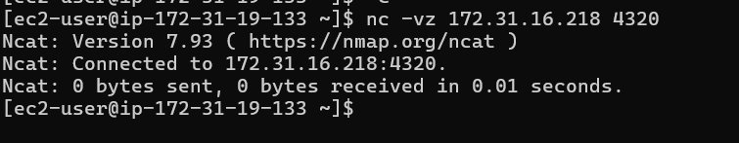

Problem: Can’t able to sent traces. Failed to connect with server.
CHANGES:
In config.yaml
Changed password to pranavpp37%40 from pranavpp37@.
Also, Here's the solution - disable OpAMP and use a static configuration instead:
Solution: Run without OpAMP
Edit the systemd service to remove the OpAMP configuration:
sudo bash -c 'cat <<EOF > /etc/systemd/system/signoz-otel-collector.service
[Unit]
Description=SigNoz OTel Collector
Documentation=https://signoz.io/docs
After=network.target

[Service]
User=signoz
Group=signoz
Type=simple
KillMode=mixed
Restart=on-failure
WorkingDirectory=/opt/signoz-otel-collector
ExecStart=/opt/signoz-otel-collector/bin/signoz-otel-collector \
--config=/opt/signoz-otel-collector/conf/config.yaml

[Install]
WantedBy=multi-user.target
EOF'

I removed these lines:
- --manager-config=/opt/signoz-otel-collector/conf/opamp.yaml
- --copy-path=/var/lib/signoz-otel-collector/config.yaml

sudo systemctl daemon-reload
sudo systemctl restart signoz-otel-collector.service
sudo ss -tulpn | grep -E '4317|4318|13133'
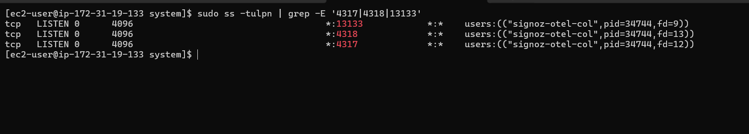

Try Sending Test Data:
Traces:
curl -v -X POST http://localhost:4318/v1/traces -H "Content-Type: application/json" -d "{
\"resourceSpans\": [{
\"resource\": {
\"attributes\": [{
\"key\": \"service.name\",
\"value\": {\"stringValue\": \"test-service\"}
}]
},
\"scopeSpans\": [{
\"spans\": [{
\"traceId\": \"$(openssl rand -hex 16)\",
\"spanId\": \"$(openssl rand -hex 8)\",
\"name\": \"test-operation\",
\"kind\": 1,
\"startTimeUnixNano\": \"$(date +%s)000000000\",
\"endTimeUnixNano\": \"$(expr $(date +%s) + 1)000000000\",
\"attributes\": [
{\"key\": \"http.method\", \"value\": {\"stringValue\": \"GET\"}},
{\"key\": \"http.url\", \"value\": {\"stringValue\": \"/api/test\"}}
]
}]
}]
}]
}"

Metrics
curl -v -X POST http://localhost:4318/v1/metrics -H "Content-Type: application/json" -d "{
\"resourceMetrics\": [{
\"resource\": {
\"attributes\": [{
\"key\": \"service.name\",
\"value\": {\"stringValue\": \"test-app\"}
}]
},
\"scopeMetrics\": [{
\"metrics\": [{
\"name\": \"test_counter\",
\"description\": \"A test counter metric\",
\"unit\": \"1\",
\"sum\": {
\"dataPoints\": [{
\"asInt\": \"42\",
\"timeUnixNano\": \"$(date +%s)000000000\",
\"attributes\": []
}],
\"aggregationTemporality\": 2,
\"isMonotonic\": true
}
}]
}]
}]
}"

Logs
curl -v -X POST http://localhost:4318/v1/logs -H "Content-Type: application/json" -d "{
\"resourceLogs\": [{
\"resource\": {
\"attributes\": [{
\"key\": \"service.name\",
\"value\": {\"stringValue\": \"test-app\"}
}]
},
\"scopeLogs\": [{
\"logRecords\": [{
\"timeUnixNano\": \"$(date +%s)000000000\",
\"severityText\": \"INFO\",
\"body\": {
\"stringValue\": \"Test log message at $(date)\"
},
\"attributes\": [{
\"key\": \"test.field\",
\"value\": {\"stringValue\": \"test-value\"}
}]
}]
}]
}]
}"

Signoz UI Password : Pranavpp37@12345
TRACES
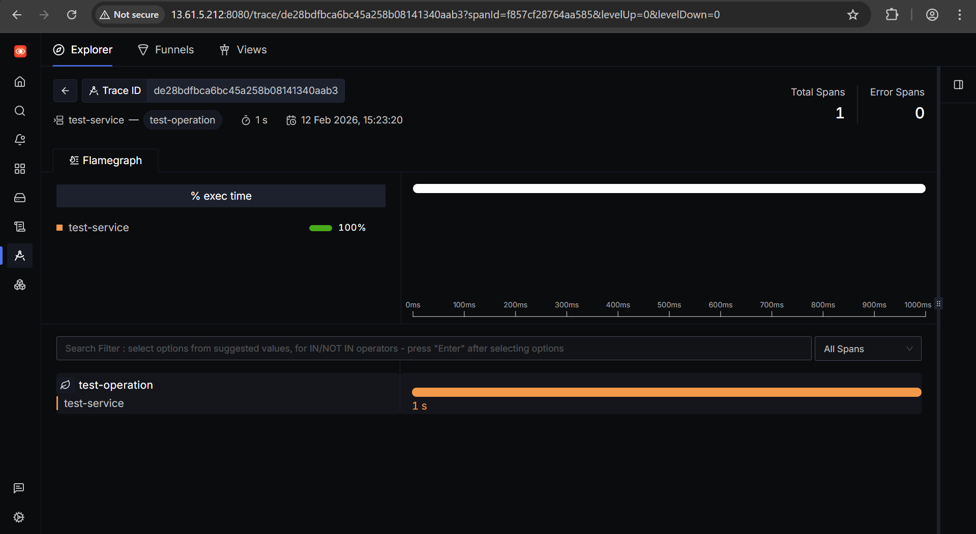
LOGS

METRICS
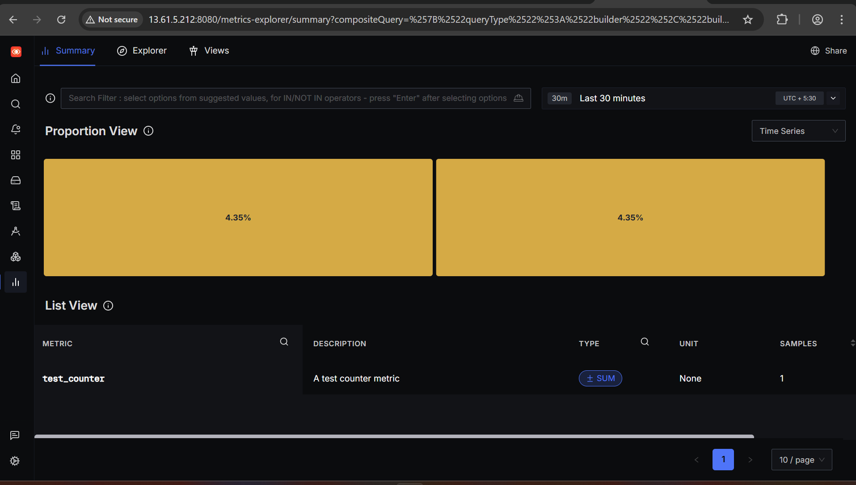

In ClickHouse VM
Traces

Logs

Metrics
